**Choosing Healthy Foods**

**In order of importance**

* Lean proteins
* Veggies
* Fruits and grains
* Healthy fats

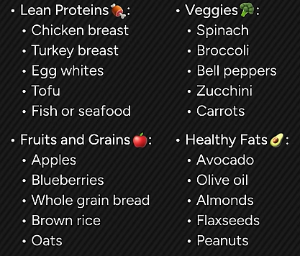

In cases where you need to eat something, but don’t have time for a whole meal, start with lean protein, then a vegetable, and so forth.

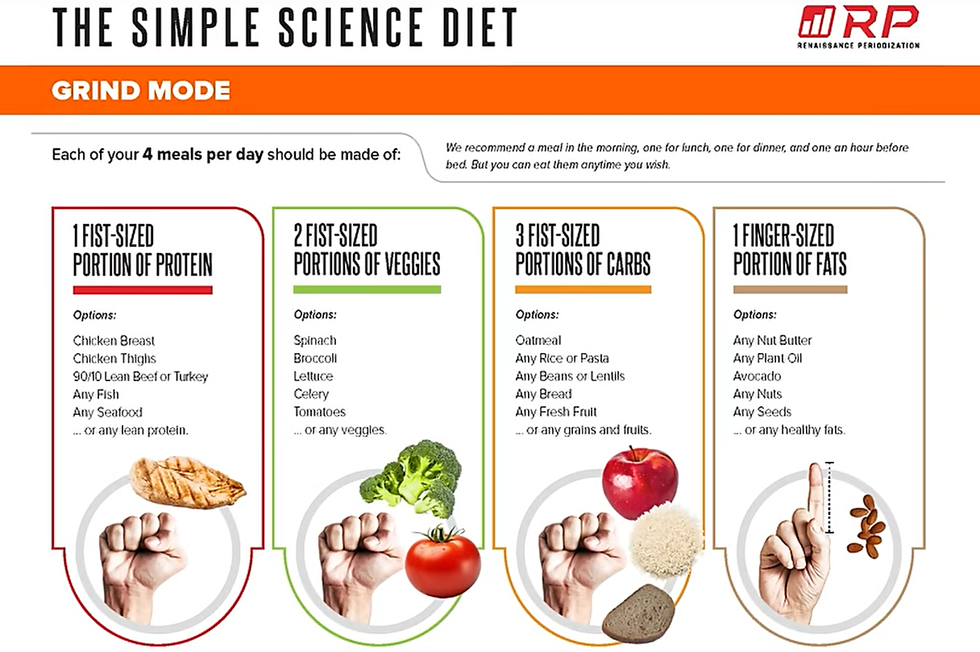

**Nine Essential Amino Acids**